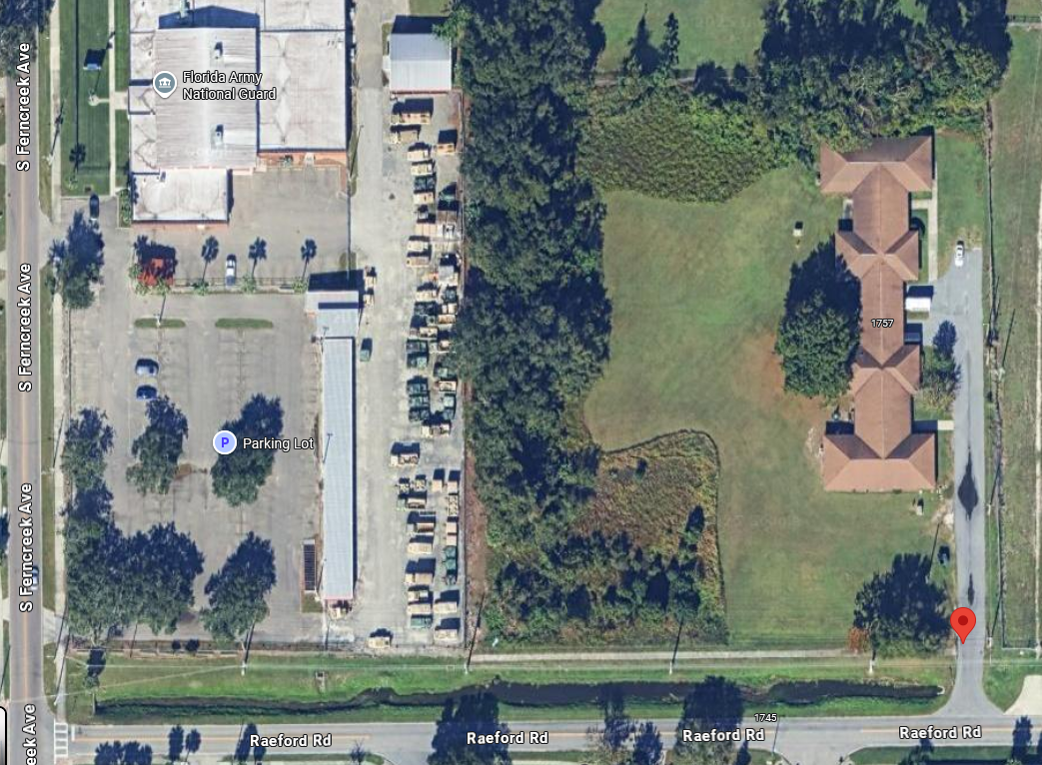
Civitan 1737 Raeford Road, Orlando Florida 32806

Cypress – 1745 Raeford Road, Orlando Florida 32806

Both addresses are under the same roofline

