
Primrose Center, Inc
Cypress and Civitan Roofing Replacement
1745 and 1737 Raeford Road, Orlando Florida 32806
(both addresses are under the same roofline_

Contractors must bid on all aspects of the project’s scope.

Scope of Work

The Proposed project covers general construction activities associated with the replacement of the existing roof and roofing system at Civitan and Cypress Residential Group homes. Primary function is to replace the shingles, soffit, facia, and other exterior roofing featurs.

Specific focus on the following areas:

- Replacement shingles and damaged under-shingle wood / base.
- Replacement soffit, facia, and damaged roofing fixtures.
- Replacement of other exterior roofing items associated with the complete replacement of the roof system.

For layout, please see: 2025 Primrose Center Birds Eye – Civitan and Cypress

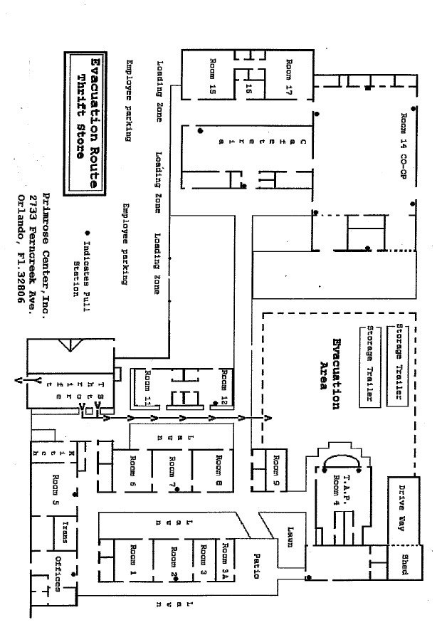
Primrose Center MAP
Admin

Details Map
Leslie North Administration Offices

Details Map
Front Building and TAP

Details Map
North Campus: Cafeteria and COOP
GEN

