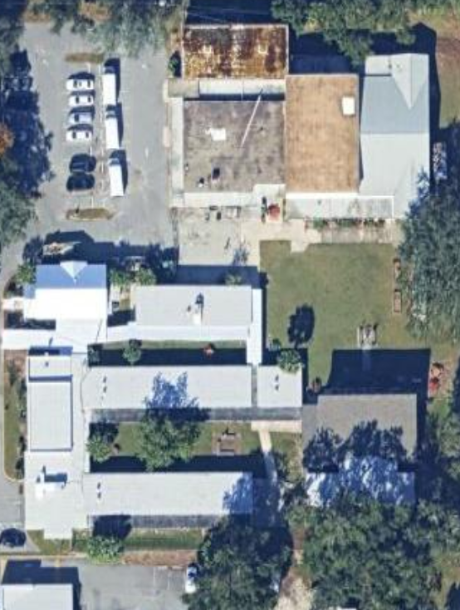
(White) Existing Gate (remains)
8
4
3
2
1
HVAC access via removable side panel or door
Blue – Black Chain Link Fence
Purple – Black Chain Link Gate
Yellow – Steel resort style Gate
Green - Steel resort style fence
Red – aluminum Resort style fence
Orange – aluminum resort Style Gate
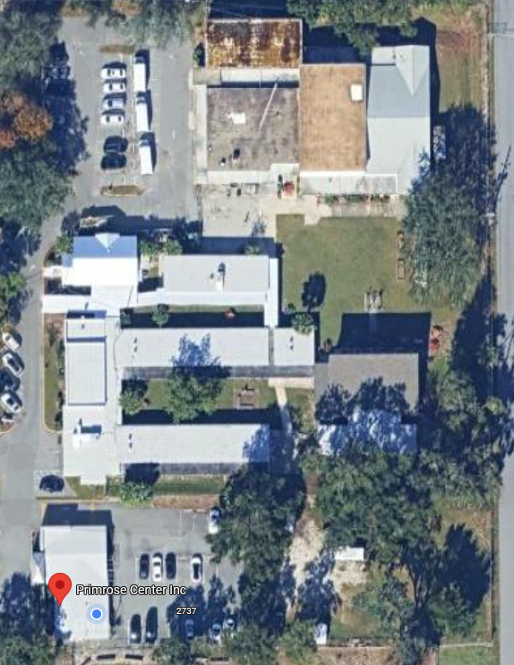
5
7
6
- There are 8 gates, but only 7 needs replace.
- Gate #8 remains since it is new
- The HVAC units at the Basketball Court will need access. A removable side or a hinged door is acceptable.

