
Primrose Center, Inc
Hurricane windows, doors and generators
2733 S. Ferncreek Avenue, Orlando, Florida 32806

Contractors must bid on all aspects of the project’s scope.

Scope of Work

The Proposed project covers general construction activities associate with the retrofit of existing buildings on the Primrose Center main campus. Primary function is to better withstand hurricanes and storms when providing services to persons with disabilities and to maintain a safe environment on campus.

Specific focus on the following areas:

- Replacement of existing windows with wind-resistant materials. (up to 189).
- Replacement of doors with wind-resistant materials. (up to 3). This included one (1) double opening French door and two (2) sliding glass doors.
- Installation of electrical generators. (up to 4).

For layout, please see: Primrose Center MAP. This includes the main campus and the Leslie North Administration Offices building.

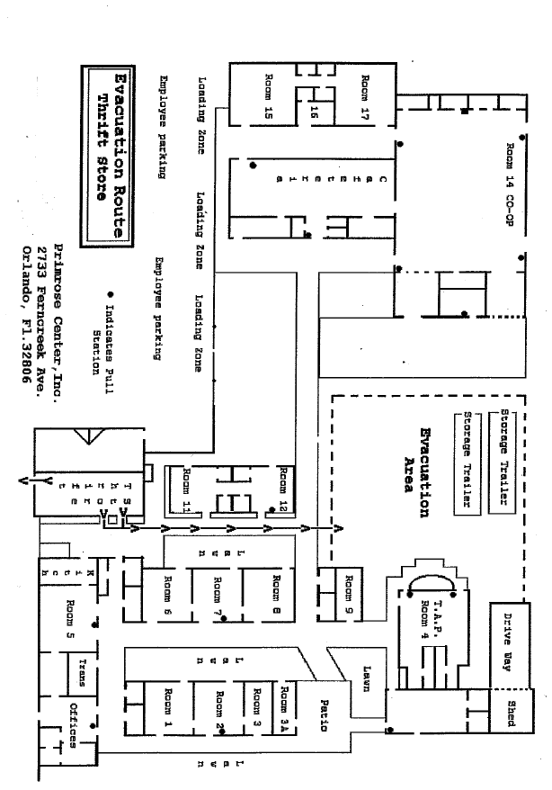
Primrose Center MAP
Admin

Details Map
Leslie North Administration Offices

Details Map
Front Building and TAP

Details Map
North Campus: Cafeteria and COOP

